ECE 426 Analog Electronics Laboratory

Lab 9 PID Beam Control
Student Handout
by Molana Torabi and Pablo Bautista-Cortezano • Week 9 • October 16, 2026
Build a two-motor beam, develop its feedback controller and tune it to hold an angle. Showcase stable balance and recovery from gentle disturbances to a TA. Nothing needs to be uploaded to Moodle.
Before lab
Bring your already printed PIDLAB.stl parts, laptop and USB data cable. Download FlightBench-1.6.8-Windows-Share.zip and Beam_Student_Tuner_Kit_20261011.zip from Week 9. Obtain the rig/PDB schematic and power/start instructions from the TA before assembly; ask if any are missing.
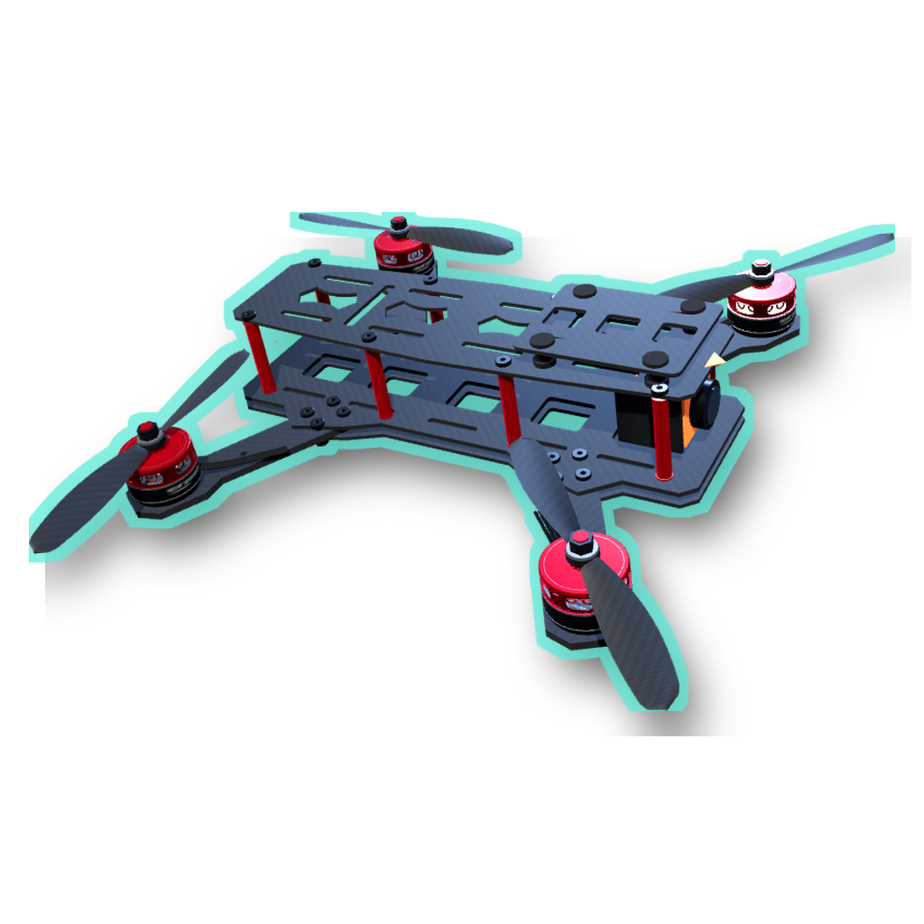
FlightBench is the app used for ESC setup, motor testing and live PID tuning.
1. On Windows x64, Extract All from the FlightBench ZIP into a local folder such as Documents\FlightBenchSetup. Run FlightBench-Setup-1.6.8.exe using the default installation location. Launch it and confirm version 1.6.8.
2. Install Arduino IDE with Teensy support. For either MPU6050 option, install Adafruit MPU6050; for LSM6DSO32, install Adafruit LSM6DS. Install Adafruit Unified Sensor and Adafruit BusIO for either path.
What the tuner kit provides
Extract the kit and read README.md, HARDWARE.md and INTEGRATION.md.
It supplies app communication, a descriptor template and calibration helpers.
It contains no completed sketch, estimator, PID, mixer, motor driver or tuned gains; you implement these.
Power and propellers
Keep the LiPo disconnected for soldering, wiring changes, uploads and propeller installation. Leave props off for ESC programming and motor tests. USB-only checks may use fitted props when ESC power is disconnected. Powered tuning requires the TA-approved guarded/restrained setup with a reachable cutoff; keep hands, face, clothing and cables clear.
The sequence
1 Assemble and wire → 2 Configure ESCs and test motors → 3 Develop and upload firmware → 4 Pass USB checks → 5 Tune the beam and demonstrate control.
System connection overview
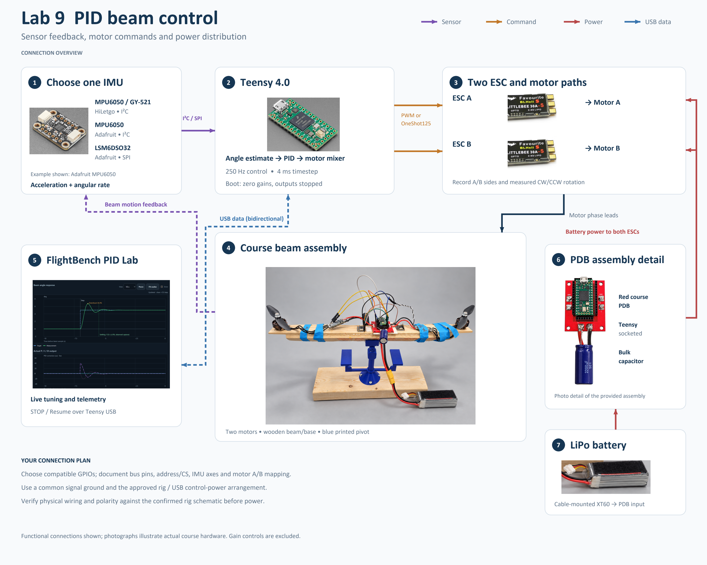
Reference diagram for the assembly and firmware steps that follow. Confirm physical connections against the rig schematic.

Part 1 Assemble and wire the beam
1.1 Collect and assemble
1. Pick up the supplied wooden beam and base pieces. Check them and your already printed parts against the rig plan.
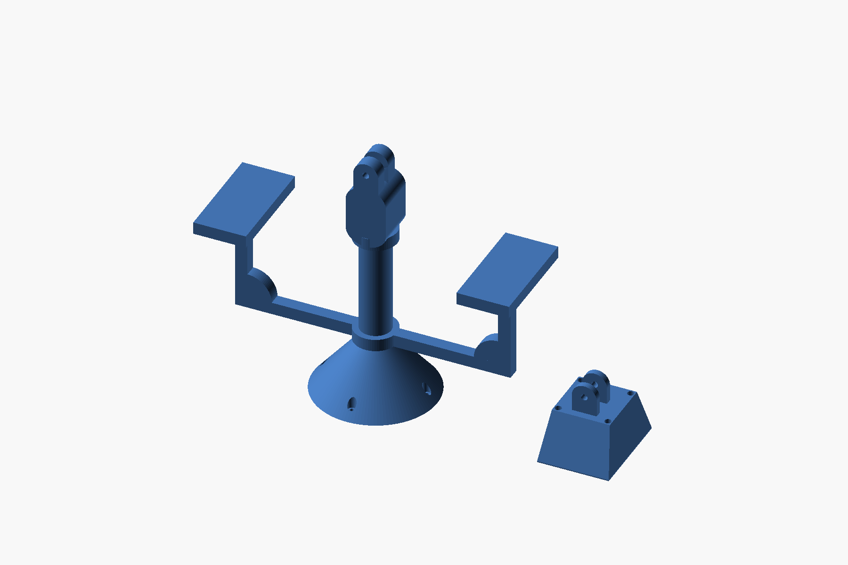  Already printed fixture parts. |   Collect the supplied wood.
2. Pull out two motors and two ESCs. With props removed, mount one motor at each end of the wooden beam. Secure the supplied fasteners without contacting the motor windings; label ends A and B.
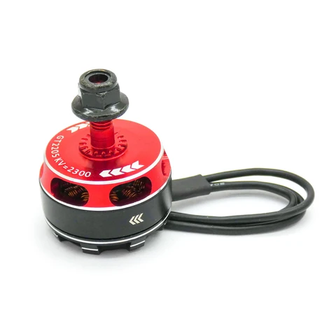  Brushless motor. | 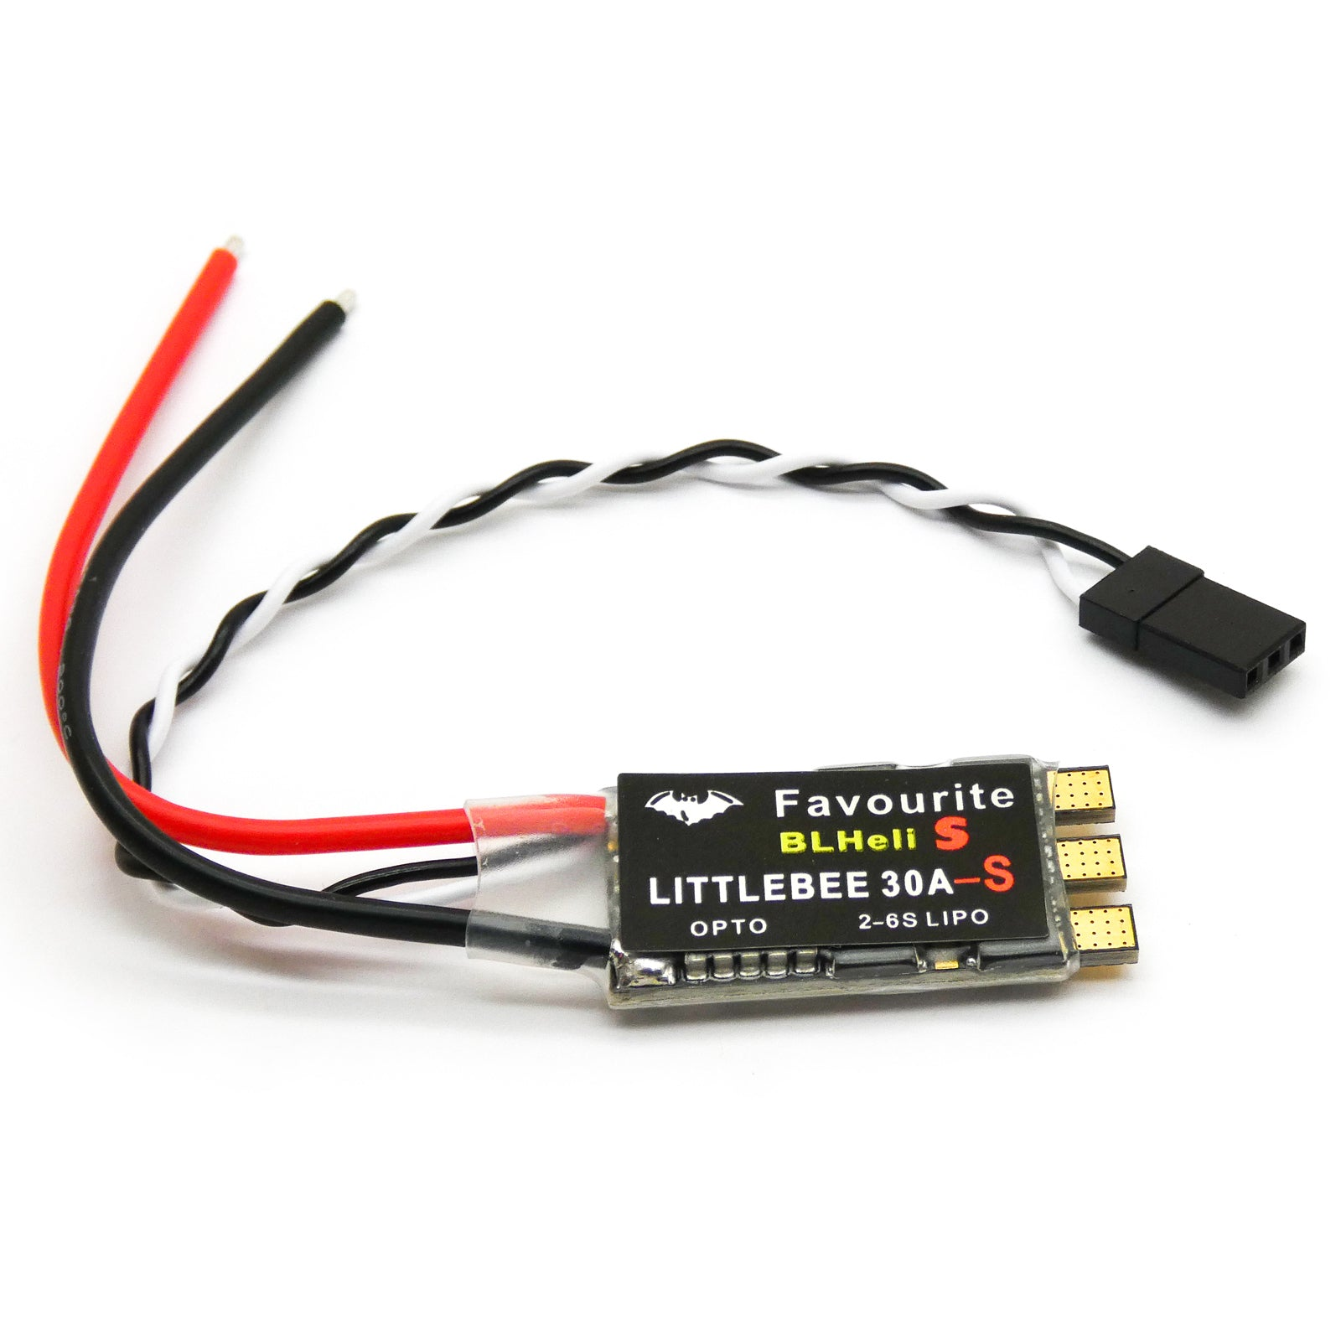  ESC.
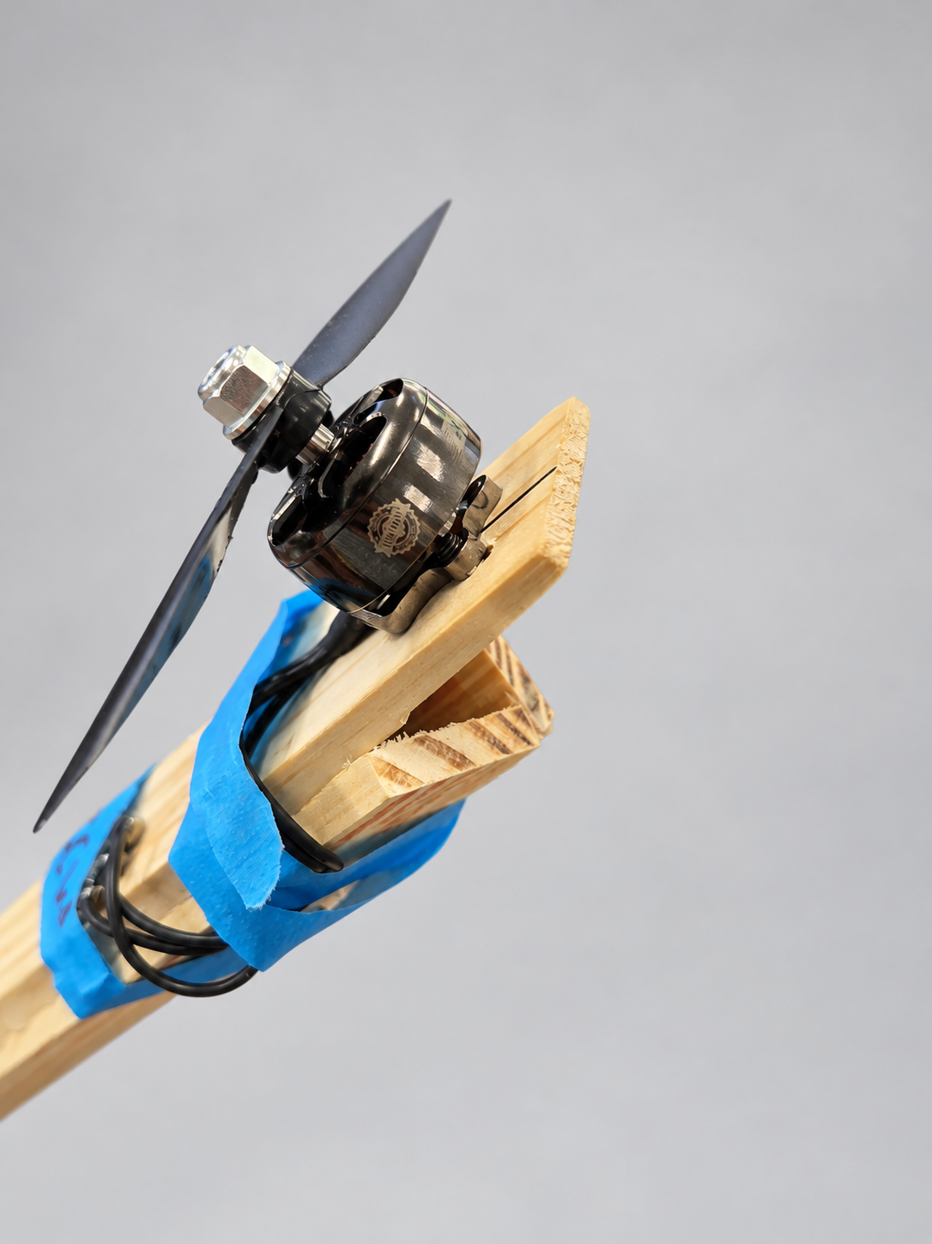  Motor mounting from above. | 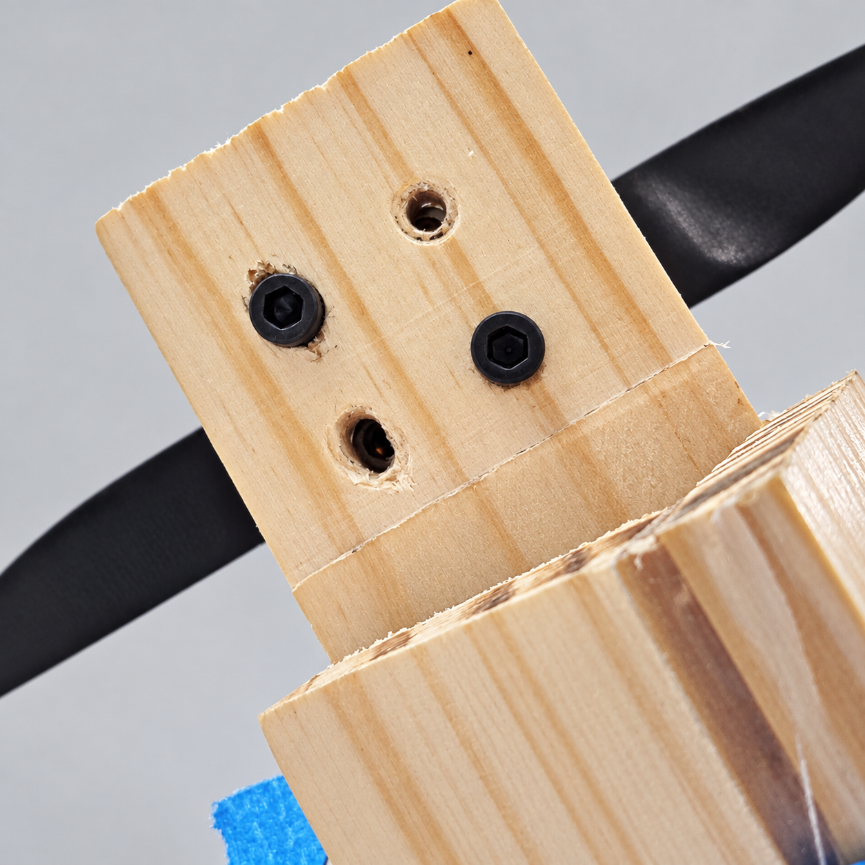  Mounting from underneath.
Mounting photos show fitted props as an assembly reference. Keep yours off through motor testing.
3. Glue or secure the wood to the printed assembly at the locations in the rig plan. Allow adhesive to set, assemble the pivot/base and check free movement and cable clearance.
1.2 Connect motor phases and PDB power
1. Connect each motor’s three phase leads to its own ESC’s three motor outputs. Insulate every joint and provide strain relief.
2. Identify the PDB pads from the schematic and board markings. Solder both ESC positive leads to the intended V+ pads and both return leads to GND. The large pads carry motor battery power; the bottom V+/GND pads accept the bulk capacitor.
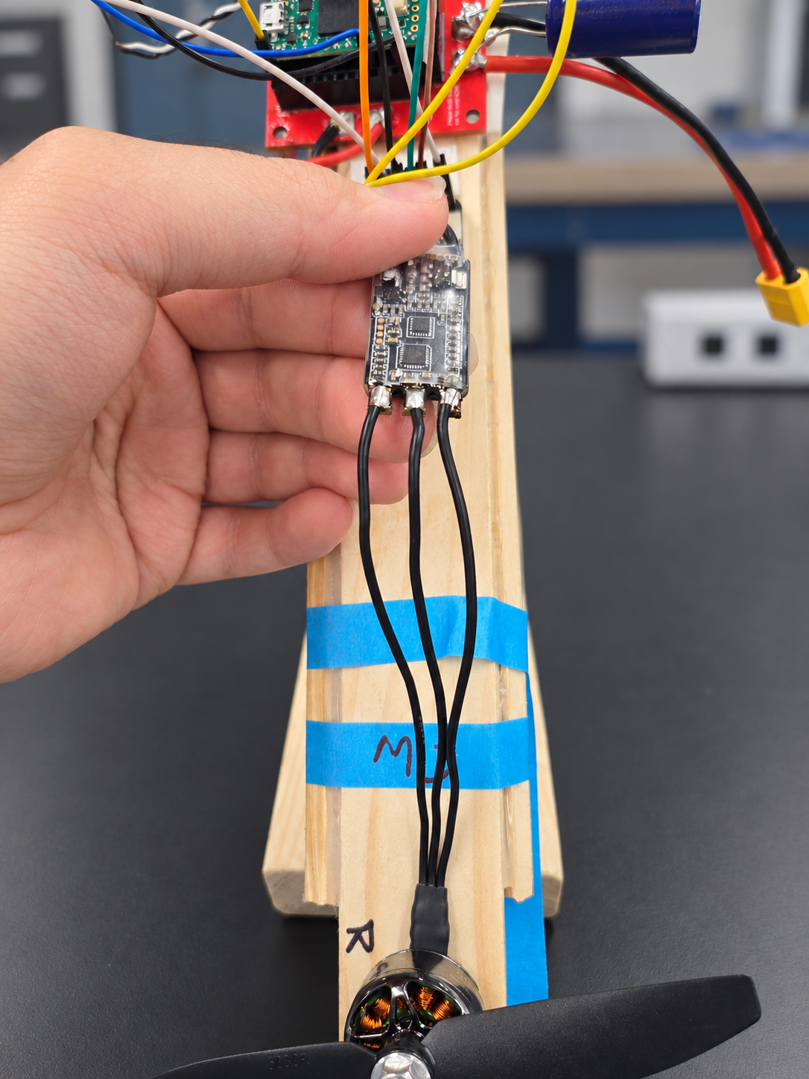  Three motor phase connections at the ESC. | 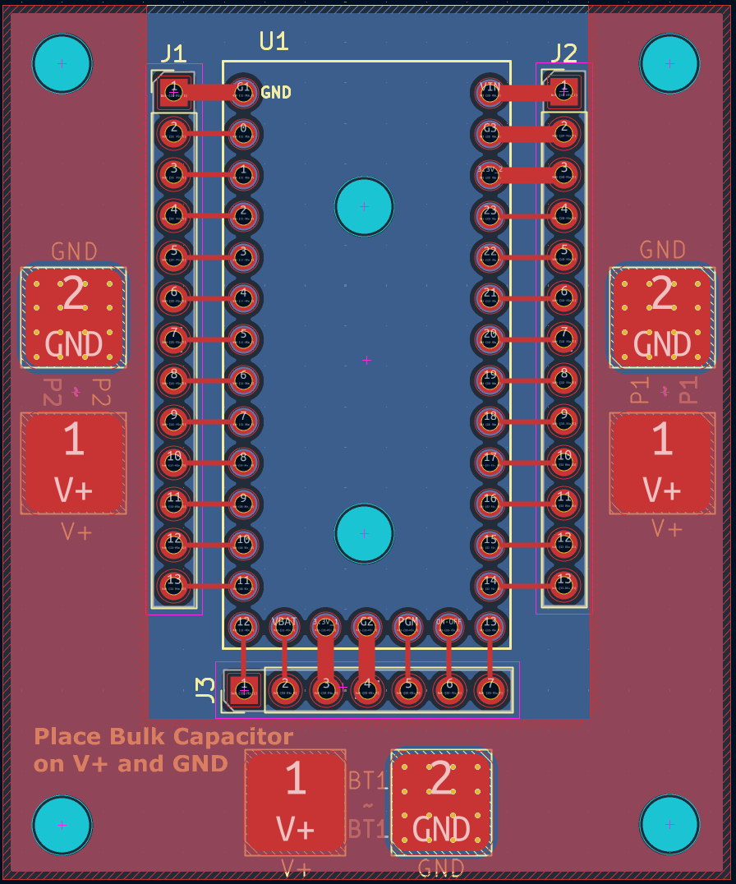  PDB layout: use the schematic and board markings.
Keep the three connection types distinct
• Motor phase leads connect the ESC to the motor.
• ESC power leads carry battery current.
• The signal/GND pair carries the control command.
1.3 Complete the PDB assembly
1. Pull out the battery, XT60 lead, bulk capacitor and Teensy 4.0. Keep the battery unplugged. Solder the XT60 lead and capacitor to the matching V+/GND pads; verify polarity and capacitor rating against the schematic.
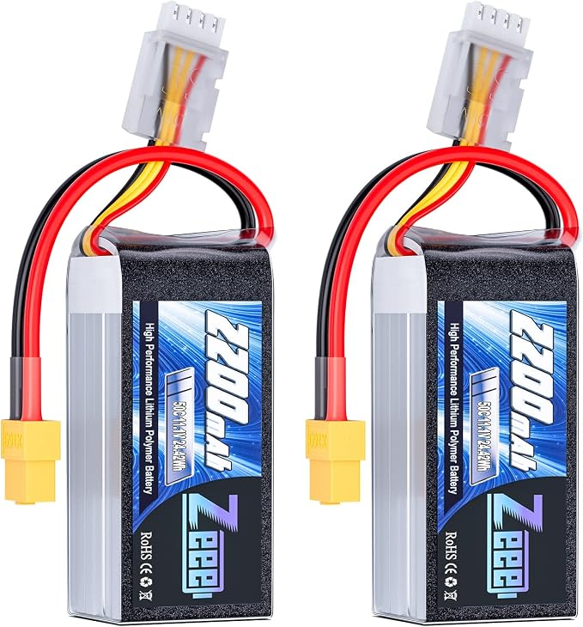  Battery. | 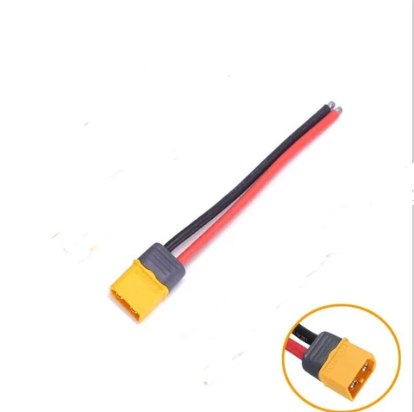  XT60 lead. | 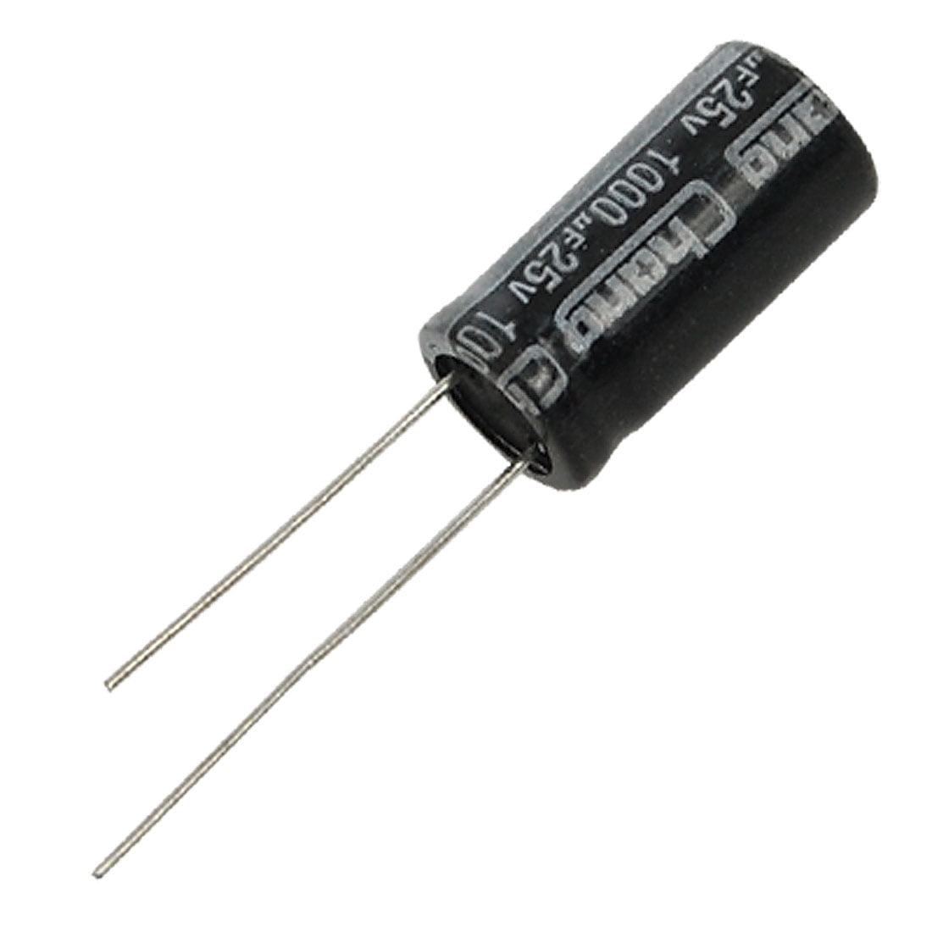  Bulk capacitor. | 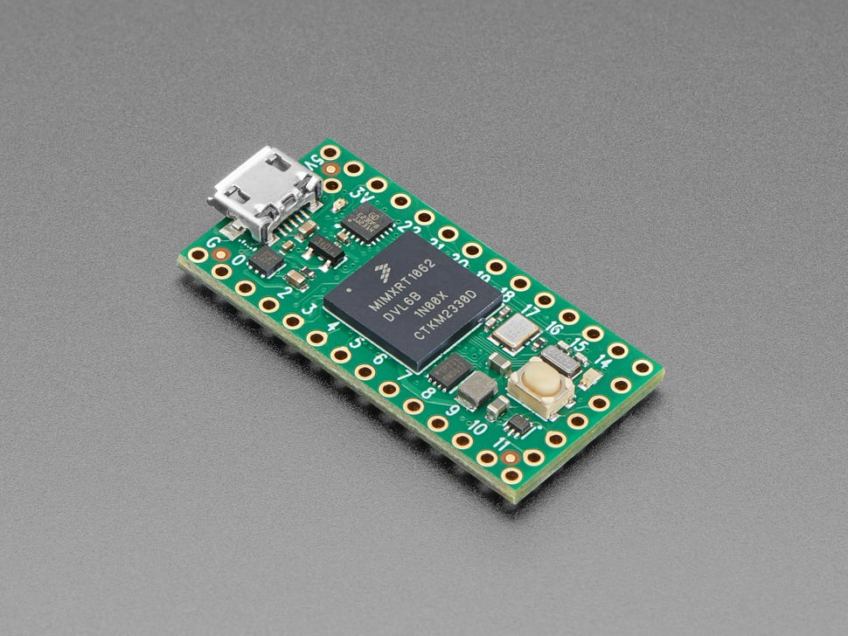  Teensy 4.0.
2. Secure the Teensy in the specified orientation with USB access. Use the approved control-power path, ESC signal connections and common ground. Never feed the motor battery rail directly into a Teensy power or signal pin.
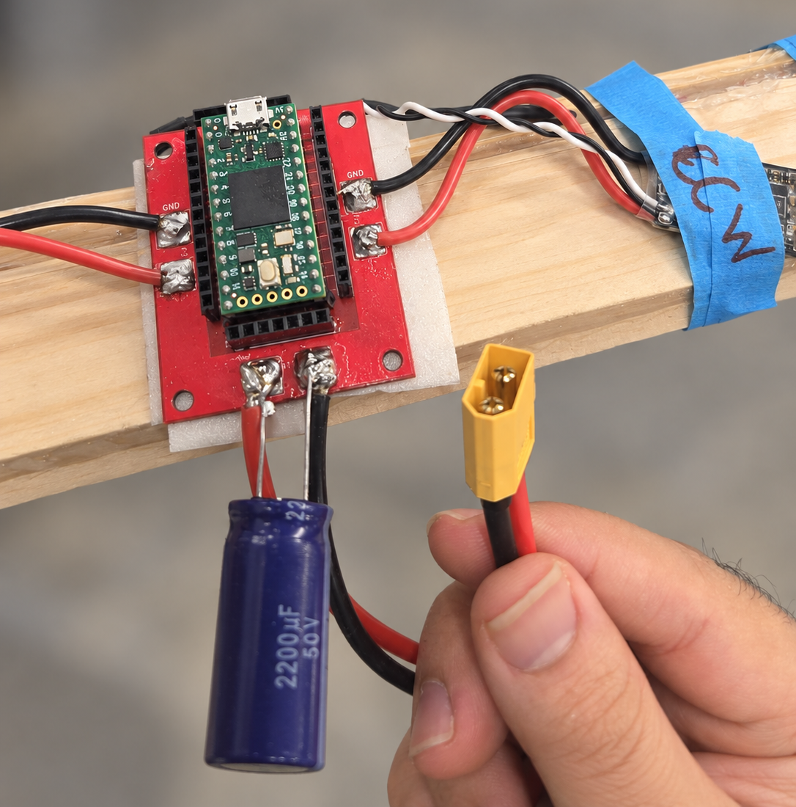
Assembly reference: Teensy, ESC power leads, bulk capacitor and the unplugged XT60. Verify actual wiring against the schematic.

Part 2 Configure the ESCs and test motors
Before applying ESC power, confirm
☐ Correct V+/GND and connector polarity; insulated joints; no solder bridges or loose strands.
☐ Compatible control voltages, secure connections and correctly labeled A/B command leads.
☐ TA wiring check completed. Choose compatible GPIOs for your own firmware; the app’s temporary programmer/test mapping is separate.
2.1 Program each ESC
Open FlightBench → ESC calibration. Work on one ESC at a time with props removed.
1. Disconnect ESC power. Connect Teensy USB, close other apps using its COM port and select “0. Install Teensy programmer firmware”. Follow Teensy Loader; press Program if requested.
2. With ESC power OFF, connect the ESC signal wire to Teensy GPIO 1. Complete and check the temporary wiring using the app’s programmer preparation guide, then supply ESC power as directed.
3. Select “Connect Teensy” → “Read & back up ESC”. Save the original 512-byte configuration with “Download first-read page”. Stop and ask the TA if identity validation fails.
4. Enter the settings below. Select “1. Stage & validate”, resolve errors, then “2. Confirm & write”. Confirm the selected ESC and wait for verification.
Setting | Value | Setting | Value
Startup power | 0.50 | Motor direction | Normal
Motor timing | Medium | Demag compensation | Low
Temperature protection | 140 °C | Programming by TX | Enabled
Low RPM power protection | Enabled | Brake on stop | Disabled
PPM minimum throttle | 1048 µs | PPM center throttle | 1488 µs
PPM maximum throttle | 1900 µs | Startup beep volume | 40
Beacon/signal volume | 80 | Beacon delay | 10 minutes

5. Keep USB connected. Remove ESC power, click “ESC power is OFF” and wait five seconds. Restore ESC power, select “ESC powered ON · reread” and confirm settings survived. Disconnect ESC power before changing connections; repeat for the second ESC and keep both backups.
Use 4 µs setting increments; center throttle is relevant only to bidirectional mode. These ESC settings do not define your firmware’s output protocol. “Run demo” previews the GUI; use the hardware workflow rather than a generic full-throttle calibration sequence.
ESC calibration interface
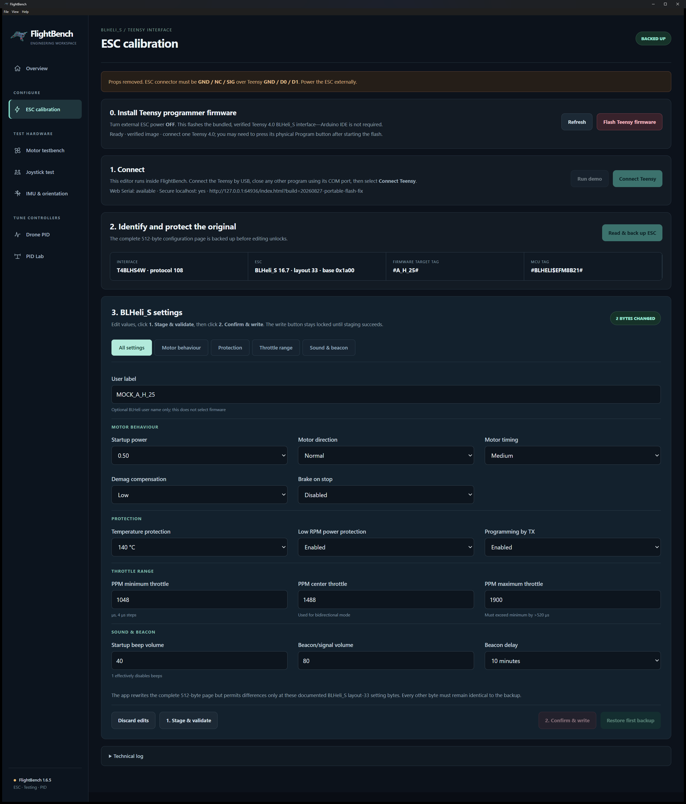
Installed ESC calibration window with the required settings, shown in demo mode.
2.2 Check motor operation and direction
1. Secure the fixture with props removed and cutoff accessible. Disconnect ESC power. In Motor testbench, confirm preparation and select “Flash motor-test code”. This replaces the programmer firmware.
2. With all power disconnected, follow the app’s diagnostic channel mapping and choose the ESC under test. Select “Connect test board” at 115200 baud. Confirm identity/preparation and the TA-approved wiring check before ESC power.
3. Select a motor and Startup preset, then “Enable test” → “Run selected motor”. Keep STOP ALL MOTORS accessible. Check smooth startup, correct CW/CCW rotation and no abnormal noise or rapid heating; record the observation and repeat for the other motor. Runs last at most 8 seconds; heartbeat loss stops outputs after 0.5 seconds.
Wrong direction: stop, disconnect ESC power and return to ESC calibration. Set that ESC’s Motor direction to Reversed, repeat write/power-cycle/readback, then retest. For other problems, stop and inspect with the TA.
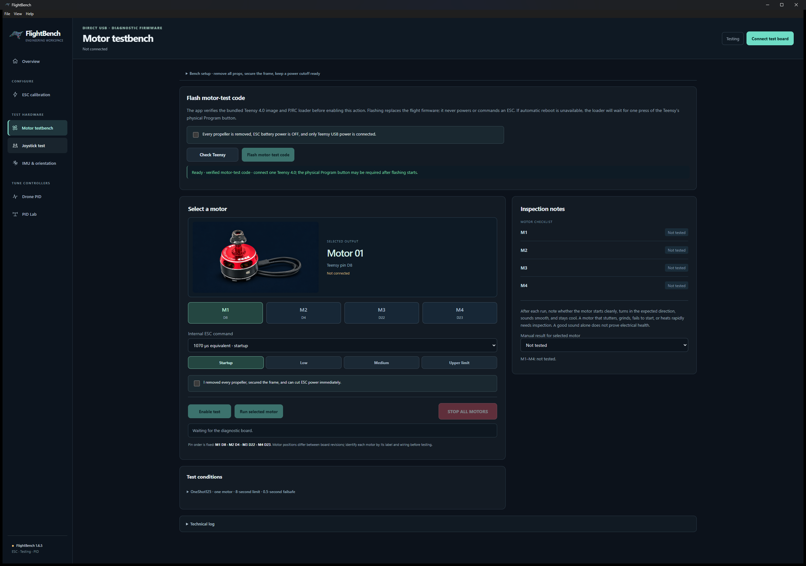
Motor testbench, shown disconnected. It records observations rather than measuring RPM or certifying electrical health.
Before developing your firmware, confirm
☐ All outputs are stopped and ESC power is disconnected.
☐ Your own beam wiring is restored before uploading firmware in Part 3.

Part 3 Develop and upload your firmware
3.1 Select and document the hardware
Use one IMU: HiLetgo MPU6050/GY-521 or Adafruit MPU6050 over I²C, or Adafruit LSM6DSO32 over SPI. Check the exact power/GND and bus pinout with power disconnected. Confirm the MPU I²C address or record the LSM chip-select GPIO. Choose Teensy bus pins and ESC signal GPIOs that support your PWM or OneShot125 implementation; document A/B pins and frame rate in your rig sketch.
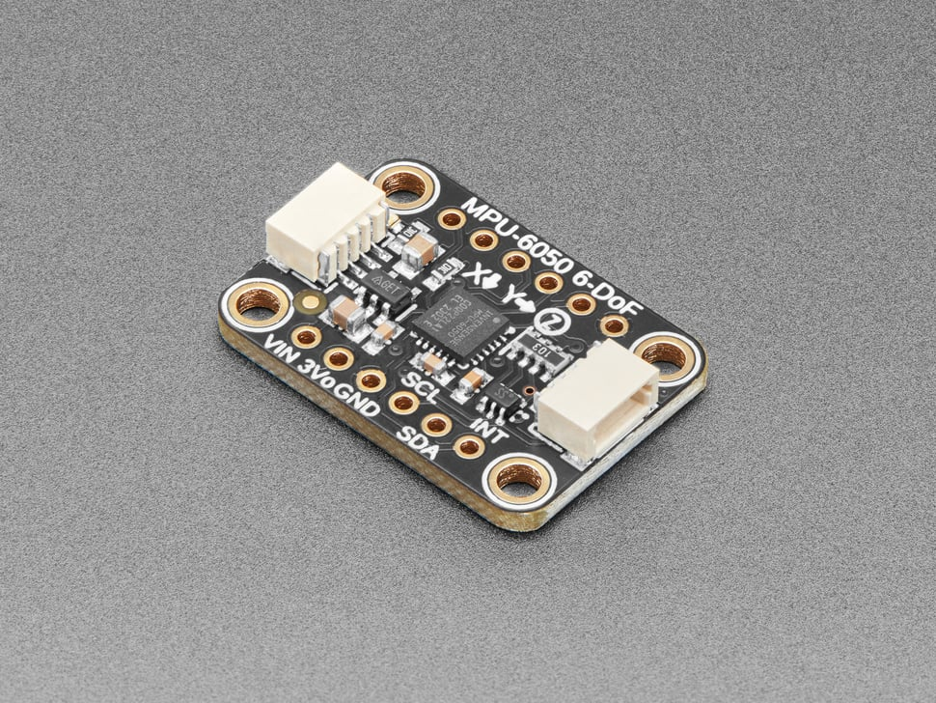  Example breakout: use your selected IMU. | 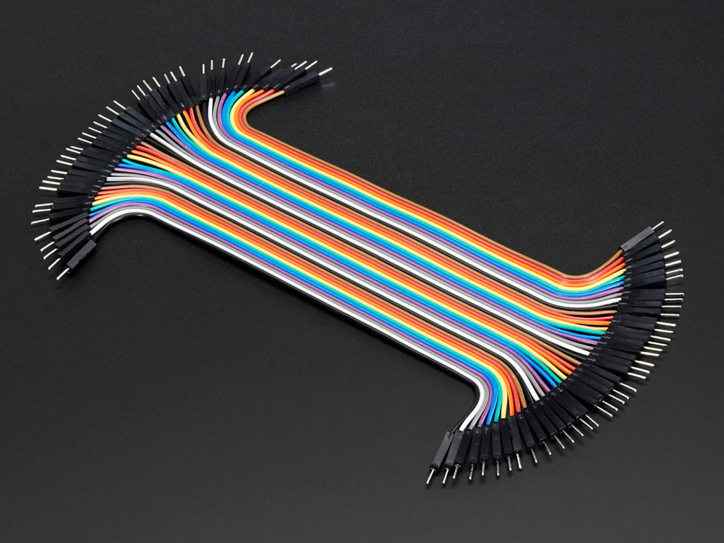  Jumper wires.
Mark +X/+Y relative to the motors, +Z/board face, the pivot axis and positive tilt. Record each A/B motor’s location, viewing direction and measured CW/CCW rotation. Read Section 3.2 before writing your AI request.
Ask your AI: “Using my labeled rig sketch, help me check the tilt axis and sensor signs. Explain why CW/CCW rotation alone does not determine the required motor correction; do not choose GPIOs for me.”
3.2 Sensor and timing hints
Use these hints when writing your AI request and checking the generated sensor code. Read the guidance for your selected IMU before code review and upload.
250 Hz means 250 estimate/PID updates per second, nominally every 4 ms. At 100 Hz the budget is 10 ms; at 500 Hz it is 2 ms. Use 250 Hz for this lab and the actual timestep in integration, derivatives and software filters. Sensor output rate, ESC frame rate and tuner telemetry rate are separate settings. Higher rates do not automatically improve the response.
Verify PWM support and its typically 1000–2000 µs pulses, or OneShot125 support and 125–250 µs pulses (1000..2000 command counts divided by 8). Verify stopped behavior, bounds and the supported output frame rate separately from control timing.
MPU6050: Explicitly configure the gyro and accelerometer sampling and filtering for the 250 Hz controller. With the digital low-pass filter enabled, a sample-rate divider of 3 produces a 250 Hz output rate. The approximately 42 Hz gyro / 44 Hz accelerometer filter setting is a starting option. Verify fresh measurements, axis directions and units, and apply calibration exactly once. Calculate software filter coefficients using the actual control timestep.
LSM6DSO32: Explicitly configure gyro and accelerometer output rates suitable for the 250 Hz controller; 416 Hz for both is a starting option. Configure and justify filtering, verify fresh measurements, and use the correct sensor class, measurement ranges, axis directions and units. Apply calibration exactly once and calculate software filter coefficients using the actual control timestep.
LSM filtering: At a 416 Hz sensor output rate, gyro LPF1 at approximately 48 Hz and accelerometer LPF2 at ODR/10 (41.6 Hz) are starting options. Enable the filters explicitly and verify their configuration. These are initial settings to evaluate, not guaranteed optimal settings. Filter high-frequency vibration before reducing measurements to the 250 Hz controller. ST datasheet, Tables 60 and 65.
Fresh measurements: Use data-ready status to identify new measurements. Attempt to acquire available fresh data before declaring a previously cached sample stale. Reusing cached data must not refresh its timestamp. Enable block-data-update and automatic register increment when implementing burst reads.
Orientation and correction direction: Match both the accelerometer angle calculation and gyro axis/sign to the actual mounting. Verify that gyro integration and accelerometer tilt agree during movement. Changing sensor orientation may also require changing the motor-mixer signs. Recalibrate after changing the mounting.
Fault reporting: Report the specific failure—incorrect identity, configuration mismatch, missing fresh data or missed deadline. For register mismatches, include the register address, expected value and actual value. Keep outputs stopped after a latched fault until the required recovery checks and explicit Resume are completed.
Adafruit LSM library: Use Adafruit_LSM6DSO32 as the sensor class. Its getEvent() return value alone must not serve as the sensor-health or freshness check. Adafruit driver.
If your LSM6DSO32 does not work on the first try, give your AI the exact module, wiring, library and error messages. Ask it to check Adafruit_LSM6DSO32, the SPI transactions and chip-select handling, and add an identity diagnostic to your own code. The course setup worked with Mode 0, MSB first, 4 MHz; WHO_AM_I register 0x0F should read 0x6C. Mode 3 gave an invalid identity. Keep ESC power disconnected while resolving the fault and verifying sensor reads.
3.3 Write your own AI request
Create a Teensy 4.0 sketch with PidLink.h and TunerDescriptor.h beside it. Attach the entire kit and your labeled rig sketch/photo to your AI. Write your own prompt using the checklist below. Review and revise the generated project; you must understand its estimator, PID and mixer. A single-loop or cascaded design is allowed when the descriptor and telemetry match.
Include | Specify or require
Hardware and orientation | Exact IMU/library/bus, chosen GPIOs, power path, axis directions and A/B motor locations/rotation.
Timing and output | 250 Hz control (4 ms), measured timestep, sensor sampling/filtering, PWM or OneShot125, verified pulse widths/frame rate and stopped command.
Control behavior | Explain the estimator, PID and mixer; hold a target and recover from gentle disturbances. Use instructor-approved motor limits in HARDWARE.md and anti-windup.
App compatibility | Use the supplied PidLink callbacks. Edit TunerDescriptor.h for your IMU, bus, protocol, rates, IDs, units and telemetry fields/order; FlightBench builds controls from it. GET/SET/RESET must affect actual runtime gains and reply with accepted values. Report angle/target/error, actual P/I/D terms and motor commands at a rate that leaves time for 250 Hz control and STOP.
Startup and faults | Zero starting gains and stopped outputs. Implement STOP, checked manual Resume and sensor/stale-data/deadline stops; no automatic restart.
Project and validation | Complete sketch/files/library list, explained signs/units/timing and staged ACCEPTANCE.md checks. Ask about missing hardware details rather than inventing them.

3.4 Review and upload in Arduino IDE
Before uploading, explain your estimator, PID, motor correction and one source of bias/noise. Trace the feedback path from IMU → angle estimate → error/PID → motor mixer → beam motion. Check these points against your rig and INTEGRATION.md:
• Trace axes and units through the sensor, estimator, PID and driver. Check motor bounds, anti-windup and both tilt directions; CW/CCW labels alone do not determine feedback sign.
• Check runtime GET/SET/RESET, atomic valid gain updates, preserved omitted fields and replies with actual accepted values. Keep descriptor IDs/units and telemetry order consistent. Send advancing microsecond timestamps and actual P/I/D contributions, not the gains.
• Service link.poll() frequently and keep blocking USB/bus work out of scheduling interrupts. Keep debug text out of protocol records. Apply kit calibration exactly once; implement physical STOP and gated Resume.
• Validate at least two AI assumptions or corrections using the kit, device documentation and rig. Keep your prompt/revisions for the TA discussion.
Ask your AI: “Review my code against INTEGRATION.md and my descriptor. Trace how a GUI gain change reaches the running controller and how telemetry returns. Identify mismatches for me to verify.”
With ESC power disconnected, open your complete sketch in Arduino IDE. Select Teensy 4.0 and USB Serial. Verify and resolve errors/warnings, then Upload. Close apps using the port and follow Teensy Loader; press Program if requested.
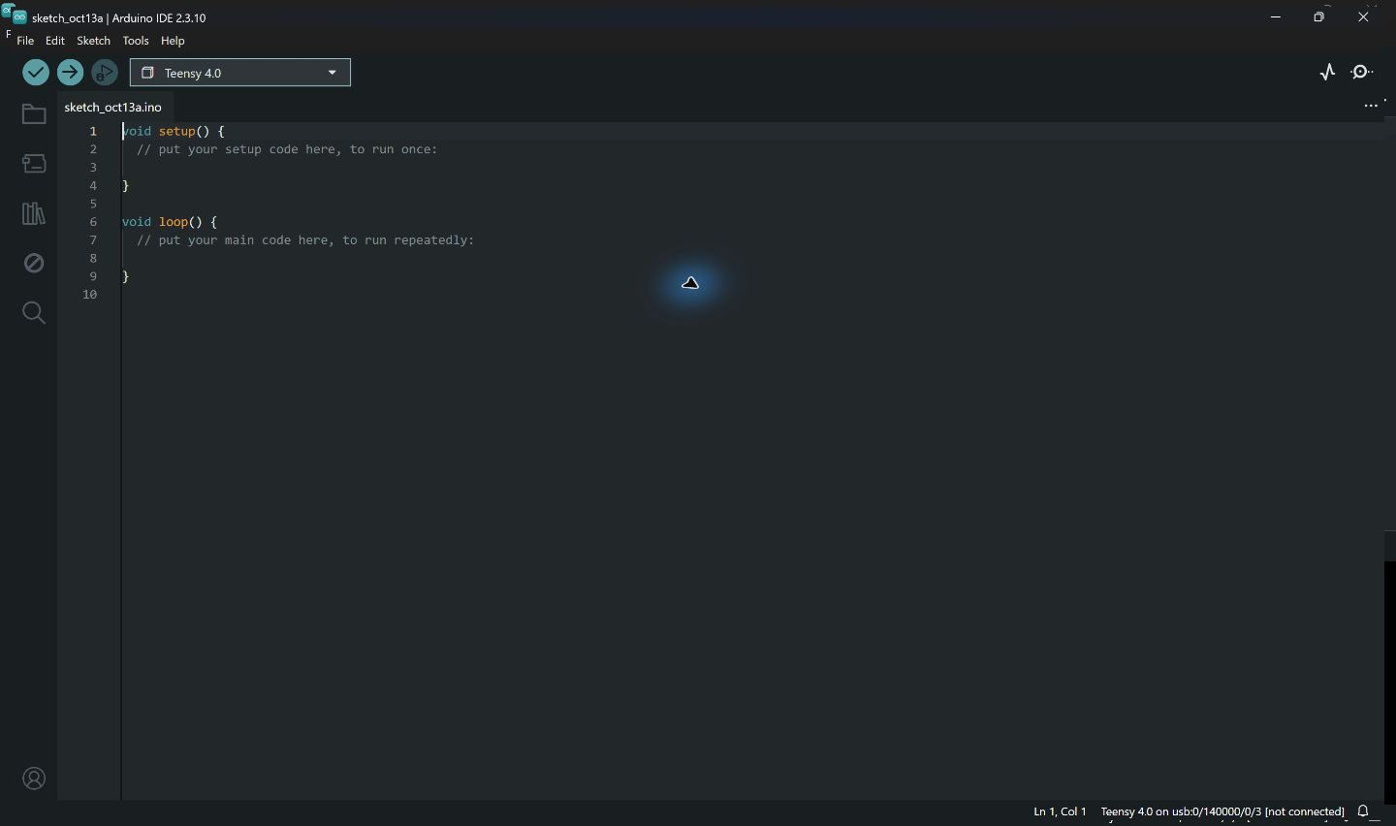
Actual Arduino IDE window: the checkmark verifies and the right arrow uploads. Open your reviewed project; this blank sketch is only an interface reference.
After reboot, outputs must remain stopped and all gains must read zero. Continue to the USB checks below.

Part 4 Pass the USB checks
Keep ESC power disconnected. Close Serial Monitor, open FlightBench → PID Lab and connect Teensy USB at 115200 baud. Complete ACCEPTANCE.md and these checks before powered tuning:
1. Discovery and startup: verify firmware/controller identity, units, zero gains and stopped outputs.
2. Sensor readings: inspect stationary and moving acceleration/gyro data. Verify freshness, units and axes; identify the tilt gyro axis and sign. Adafruit reports rad/s and m/s². Return uncalibrated deg/s and g to the kit callback: convert units without subtracting saved offsets there. Keep cached samples’ original timestamps.
3. Calibration: hold the beam level/still, calibrate, save, reboot and check readback. Apply offsets exactly once. Clear old calibration and recalibrate after changing sensor, mounting or axis mapping.
4. Live controls: test Apply/Read, Reset to zero and rejection of invalid updates. Confirm accepted values reach the running controller.
5. Correction: raise each end while outputs stay stopped. Check that angle/error and predicted motor commands oppose both tilts. Fix sensor or mixer signs if they reinforce motion.
6. Timing and faults: with ESC power disconnected, use a TA-approved oscilloscope or logic analyzer to verify ESC pulse widths/frame rate and instrument the 250 Hz loop timing. Check physical STOP and missed deadlines using ACCEPTANCE.md. Faults stay stopped until recovery checks and explicit Resume. Never force faults with powered props.
Before powered tuning, confirm
☐ The USB acceptance checks pass.
☐ Correction direction is verified.

Part 5 Tune the beam and demonstrate control
5.1 Prepare the powered test
In lab, disconnect the battery and fit the matched CW/CCW propellers to the verified motor directions. Secure them and handle blades carefully. Keep hands, face, clothing and cables clear. Secure the beam in the TA-approved guarded/restrained setup with the cutoff accessible before applying ESC power.
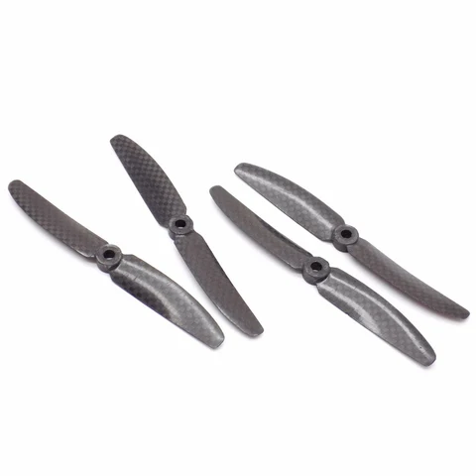
Matched CW and CCW propellers.
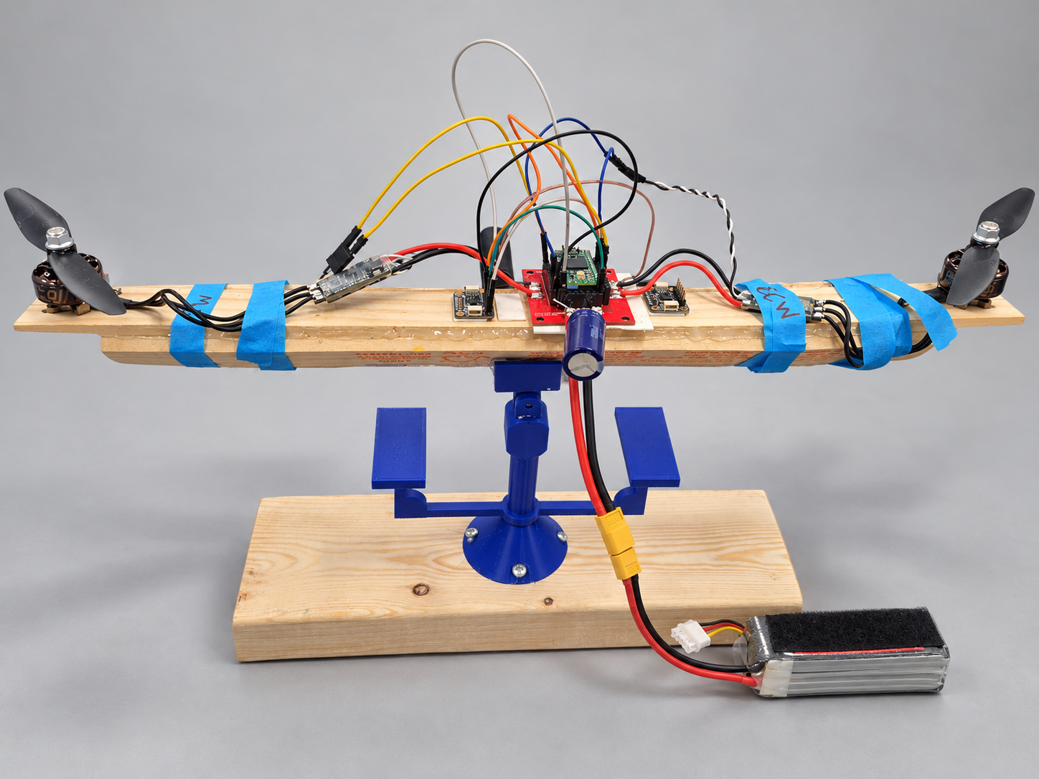
Assembled beam and battery connection. Disconnect the battery for assembly or wiring changes; use one IMU and secure signal wiring before power.
Ask the TA to check the guarded/restrained fixture and walk you through the powered start procedure before the first trial. Resume must enforce the calibration, fresh-data and level/stillness gates in HARDWARE.md. A restored sensor alone must not restart the motors.
5.2 Tune one term at a time
1. Start with Kp = Ki = Kd = 0. Increase P gradually under the approved powered-test procedure. Use the same target, starting angle and small disturbance. Reduce P for persistent oscillation or saturation.
2. Hold P fixed and add D. Compare damping, overshoot and settling; increased noise calls for checking sensor, mounting and timing.
3. Add only enough I to reduce steady error. Watch windup and slow recovery; retain integral/output limits.
4. Compare at least three gain sets on the live angle/target plot. Explain the changes and your final choice. Use one stated settling band across trials; FlightBench’s ±5% step annotation is a plotting aid.
Ask your AI: “Using my angle/target plots, help me distinguish oscillation, steady error and saturation. Explain the likely roles of P, I and D without choosing gains for me.”
Tune until the beam balances steadily near the target and returns toward it after a gentle disturbance, without sustained oscillation or repeated saturation.
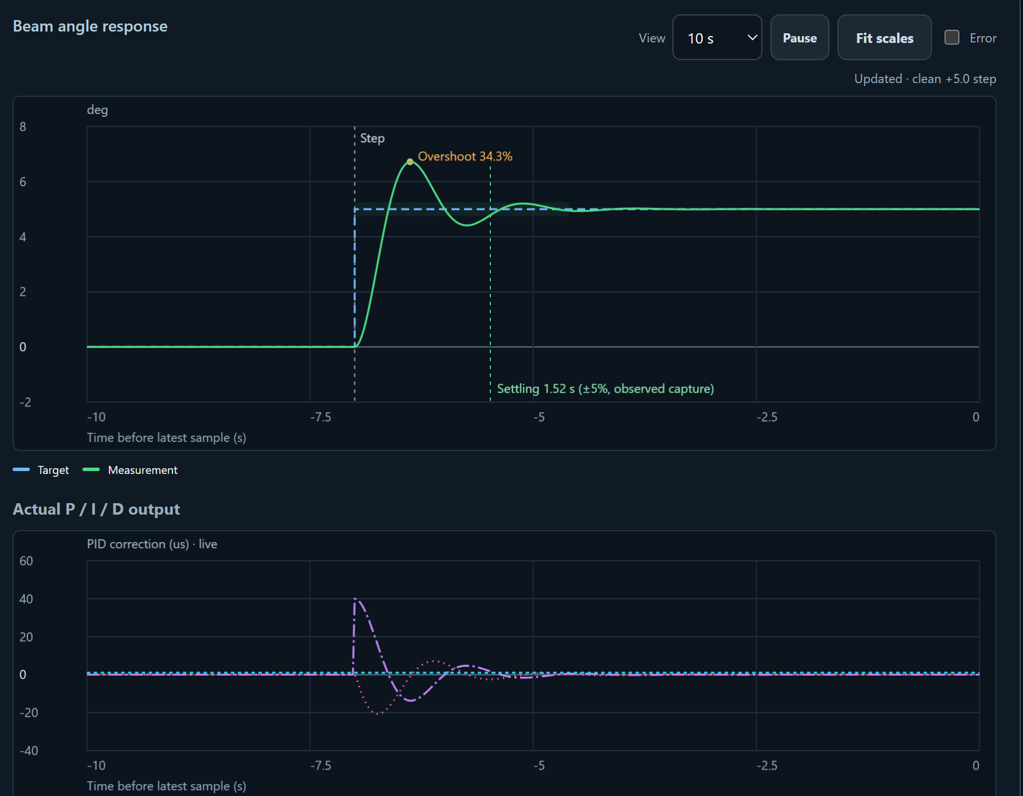
PID Lab angle/target and actual P/I/D graphs with simulated data; gain controls are excluded. The ±5% step annotation is a plotting aid, not a showcase grading threshold.
If the response is wrong
Symptom | Stop and check before retrying
Motion reinforces tilt | Sensor signs, A/B labels and mixer direction.
Persistent oscillation | P level, damping, mechanical play, noise and timing.
Drift or offset | Calibration and mechanical bias before increasing I.
Saturation or slow recovery | Output headroom, integral limits and gains.
Fault or refused Resume | Specific reported cause and recovery gates; keep the interlock.

5.3 Showcase your working beam to a TA
Bring the beam and laptop with your code project and tuner ready. Show stopped startup, steady balance and recovery when the TA gently unbalances the beam using the approved disturbance method. Keep hands clear of props. Show the live plot and demonstrate STOP. Be ready to explain wiring, tuning choices, fault/cutoff code and two AI checks/corrections.
Explain how estimation, error, PID and motor mixing connect to drone control, plus one additional drone capability and one limitation of the beam test. A simulated or sensor-only plot is not a working-beam demonstration. If no approved showcase is scheduled, ask the instructor to arrange one. Nothing is uploaded to Moodle.

